Configuring Syslog, NTP, and NAT

Student Name
Affiliation
Course No, Course Name
Instructor
Due date

Configuring Syslog, NTP, and NAT
Introduction
According to the previous network definition, response time is a critical attribute of a network. The continuity and disaster recovery of any enterprise depend on its reliability and security. Network administrators deploy multiple services on Cisco devices to obtain information about network elements and monitor the network activity. They can also view and synchronize clock displays in multiple devices. Besides, to make local computers connected to the internet.
The services offered by the router include syslog, Network Time Protocol (NTP), and Network Address Translation. This module is about Syslog, NTP, NAT, and their configuration.
Syslog Configuration
Devices on the network send messages to the system. The logs' troubleshooting enables a network administrator to manage the system.
Let’s see how we can configure a Cisco router for Syslog.
- Access the CLI and use the command configure terminal to enter global configuration mode.
- Type the command logging host 192.168.1.100, where the IP is the Syslog server..
- Turn on informational logging with TRAP logging information.
- Use the command Write memory to save the configuration.
- Check if log messages are sent.
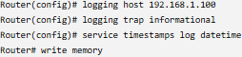
Setting up network time protocol.
When all the devices in a network operate using the same clock, it is referred to as network synchronization.
This is mainly attributed to Network Time Protocol (NTP). In computer networking, having the computer systems in a network synchronized in time is very essential.
Access the global configuration mode. Make sure your NTP server address is 192.168.1.200. Check synchronization by entering show ntp status. To show ntp associations, use show ntp associations. Use write to save the config.
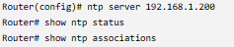
Setting up Network Address Translation.
NAT is to the procedure that overloads the header information about the network address from one IP address space to another. It is done during the transfer of a packet.
The internal interface is configured with ip nat inside. Next, set the external interface with outside IP NAT. Also, ensure access control by using access-list 1 permit 192.168.1.0 0.0.0.255. Following this, allow NAT overload using an IP NAT inside source list on GigabitEthernet0/1 overload. Check out "show ip nat translations" for translations. Finally, a ping from an internal device to an external one.
A successful translation indicates that the internal device can be accessed from the outside using a private address.
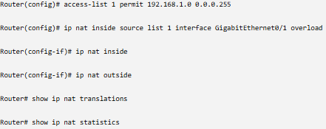
Conclusion
Every business must have disaster recovery. Similarly, if we look at disaster recovery, event logging is an important part. That is possible with syslog. NTP, NAT, and Syslog are widely used by junior network engineers. Therefore, centralized logging is provided with the purpose of event messages. Here's more of a paragraph on NTP, NAT, and Syslog. The troubleshooting process becomes much simpler.
For instance, pinpointing and resolving issues in the network will likely become easier. All devices on a network must be in sync in terms of time and date, and this is only possible with NTP.

